Friends of Northampton Castle

www.NorthamptonCastle.com

facebook.com/NorthamptonCastle

Twitter.com/NptonCastle

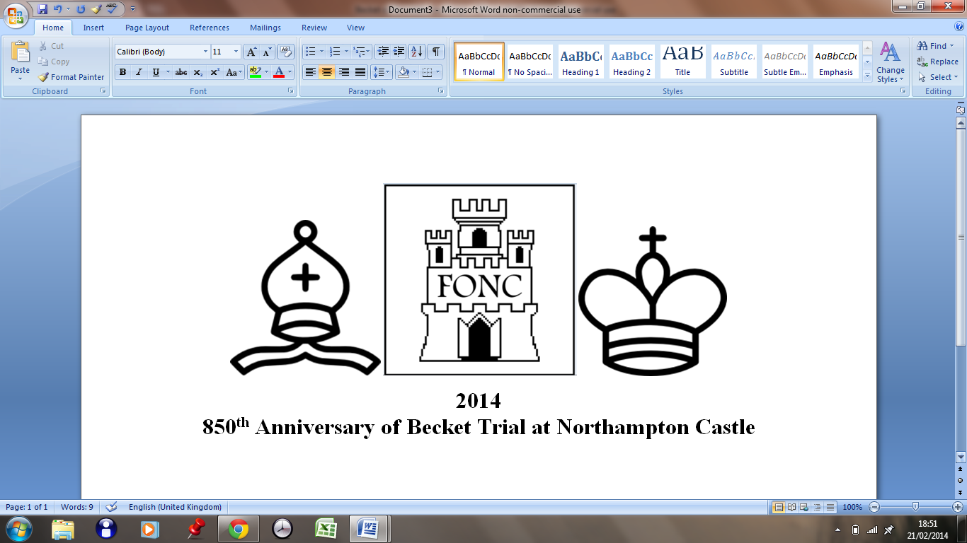

My picture of the **Trial of Thomas Becket at Northampton Castle in 1164**